DIGITAL METER PROJECT REPORT

Shivneet Kumar, Valraj Singh, Kritish Singh, Yash Maharaj  
  
ss11199367, s11197618, s11195619, s11196606

# Introduction

Embedded systems are universal in the modern world, shaping how we interact with technology, and facilitating a wide array of applications, from consumer electronics to industrial automation. At the heart of these systems are microcontrollers, compact computing devices designed to govern specific operations of a system. One such influential microcontroller is the PIC18F8722, developed by Microchip Technology [1] . This microcontroller, belonging to the 8-bit family, boasts high-performance computing, enriched Flash program memory, and a comprehensive suite of peripherals. This intricate design and robust capabilities make the PIC18F8722 an ideal choice for a multitude of embedded system applications [1]. This project explores a project that integrates this powerful microcontroller with the HC-SR04 ultrasonic sensors and hypothetically improving it with YF-S201 water flow sensor, showcasing an innovative interplay of these technologies.

Ultrasonic sensors have gained momentum in the realm of distance measurement applications due to their high precision and cost-effectiveness. The HC-SR04 ultrasonic sensor operates on a simple yet effective principle. It emits ultrasonic waves, which, upon hitting an object, are reflected to the sensor. The time taken for this round trip is then used to calculate the distance to the object [2] .Thanks to its high accuracy and versatility, the HC-SR04 sensor is employed in a broad spectrum of real-world applications. In the world of robotics and automation, it plays a pivotal role in object detection, navigation, and avoidance systems [2]. Moreover, this sensor is increasingly being incorporated in security systems, contributing to intrusion detection, and surveillance operations [3]. With the advent of IoT (Internet of Things), the utility of the HC-SR04 sensor has expanded further, serving in a variety of IoT-based applications [3].

In the project under discussion, the HC-SR04 ultrasonic sensor has been coded with the PIC18F8722 microcontroller to measure the volume of a bucket with a fixed radius and height. This project essentially demonstrates a practical application of this technology, wherein the sensor calculates the distance to the water surface in the bucket, and this data is then used to compute the volume of water in the bucket [4]. This approach takes advantage of the precise nature of the HC-SR04 sensor and the computational capabilities of the PIC18F8722 microcontroller, offering an efficient and accurate volume measurement system.

While the primary feature of the system lies in volume measurement, the project does not limit itself to this application. Recognizing the flexibility and versatility of the employed technologies, the project has been augmented to measure volumes of buckets with variable dimensions as well. This adds a layer of complexity to the problem at hand as the variation in dimensions necessitates the consideration of the shape of the container for accurate volume measurement [4]. Moreover, the system's application has been further broadened to include the measurement of the height of a person as an additional feature, highlighting the multifaceted capabilities of the setup [4].

Another key component of the project was the YF-S201 water flow sensor, a device adept at measuring the rate of water flow. This sensor finds extensive use in fluid control systems, irrigation systems, and various environmental monitoring applications [5]. In this project, the YF-S201 sensor was supposed to be employed for the measurement of water volume in a bucket that exhibits a change in radius per height. This allows the system to handle containers of irregular shapes, thereby enhancing the project's scope and versatility; however, due to its complexity in its code in PIC18 and time constraint the idea was removed.

This project was made possible by leveraging the insights gained from a wide array of scholarly articles, technical datasheets, and authoritative textbooks. These references, which have been meticulously cited below in the IEEE citation format, have played a crucial role in shaping the project and guiding its development.

At its core, this project stands as a testament to the versatility and potential of embedded systems in solving real-world problems. By effectively leveraging the computational prowess of the PIC18F8722 microcontroller and the precise sensing capabilities of the HC-SR04 ultrasonic sensor and YF-S201 water flow sensor, the project presents a comprehensive solution for volume measurement. The versatility of this solution is further underscored by its expanded applications, including volume measurement of variable buckets and height measurement of a person. This demonstrates how flexible and adaptive such a system can be when designed with innovation and practical utility in mind.

Further details on the features of the project, the intricacies of coding the ultrasonic sensor using the PIC18F8722 microcontroller, and the integration of the YF-S201 water flow sensor, along with a comprehensive overview of the project's execution, will be elaborated in the ensuing presentation. Through this project, we aim to contribute to the field of embedded systems and showcase the potential of these technologies in crafting innovative solutions for complex problems.

# Problem statement and Objectives

## Problem statement

Digital Meters are devices that measure the usage of a liquid as well as the distance of an object from a point. It can be used to monitor the level of a liquid in a reservoir, consequently, it can also assist the user in identifying any protentional leaks due to a change in water level. Therefore, the team was required to design and realize a system that uses a PIC18F8722 Microcontroller to implement a Digital Meter that shall measure the volume of a liquid in a circular storage device as well as accurately, measure a height of a person. The PIC18F8722 Microcontroller should be calibrated to communicate with 2 sensors for the input as well as an LCD Display to show the output.

## Objectives

* + 1. Measure accurate distance of the obstacle from the sensor
    2. Meter to measure a quantity of liquid in the bucket
    3. Buzzer indicator- max value
    4. Display on LCD or 7-Segment LED

# System description

## Overall system description

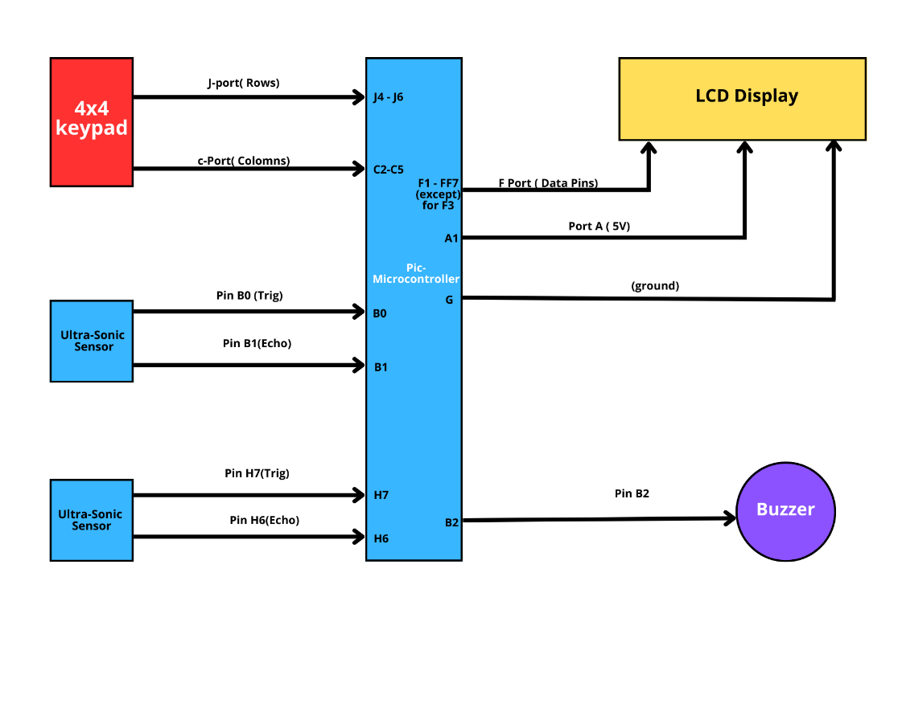

Figure :Block Diagram for the Digital Meter

Figure 1 shows the block diagram of the Digital Meter. The diagram illustrates the pins and ports that shall be used to input and output data across the system. The block diagram was sketched during the planning phase of the Project. It was done to give the team a visual representation of how the circuitry will be laid out after the completion of the Project. In the Block Diagrams, there are several key points to note. Firstly, the hub of the entire system is the PIC18F8722 Microcontroller which is connected to all other components and will act as the brain of the Digital Meter. There are 2 input devices in this system which are the Ultrasonic Sensors and the 4x4 keypad. The input devices will let the user choose the mode and provide data to the PIC18F8722 Microcontroller to compute the relevant distance and volume. The Block Diagram was then further developed to create a circuit diagram as shown in Figure 3

Table 1: Pin Allocation Table:



**Keys**



The team created a tabulated form of the Pin Allocation. This was done to ease the connecting process of the Project as well as be a reference table for all Team members to review during the circuit set-up.

## Detail system description

**Shivneet is finalizing it**

# Components required

**Table 2: Digital Meter Parts List**



# Methodology

* 1. The following methodology is proposed:
     1. The parts required were discussed and agreed upon as shown in Table 2.
     2. A flowchart was drawn to identify the sequence of events and interrupts during the measuring process as shown in Figure 1.
     3. Each respective component was researched the Pin and Port layout was identified via the Datasheet as shown in Table 1
     4. Each component was then tested to ensure that they work properly without errors, some of the criteria were;
        1. The PIC C 18F8722 Microcontroller should have all functioning pins and ports
        2. LCD Display should have all pins intact as well as display all necessary characters
        3. Ultrasonic sensor should be able to send out ultrasonic waves and deliver the round time continually
        4. Buzzer should be able to sound properly
     5. A draft circuit was formulated and built in a simulation software (TinkerCAD [6]) to check for functionality and feasibility as shown in Figure 2.
     6. The PIC C Code was then programmed to add logic to the entire system such as;
        1. Compute the volume of a cylindrical storage device.
        2. Compute the Distance between the Ultrasonic Sensor and an object.
        3. Create pathways to enable user to choose between modes.
     7. The PIC C Code was then integrated into the 18F8722 Microcontroller using the PIC C Compiler Application.
     8. All the hardware components were connected to each other via the Breadboard.
     9. The system was tested for any bugs
     10. Once finalized, all of the components were then fixed onto a mount for mobility and structural integrity. All the component were then permanently, soldered to avoid any disconnections during transportation.

# Circuit connection

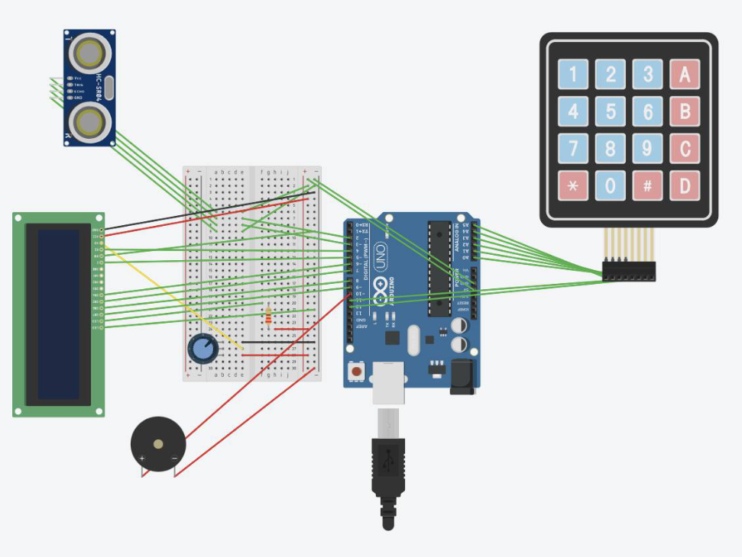

Figure : Circuit Set-up in the TinkerCAD Simulation Software

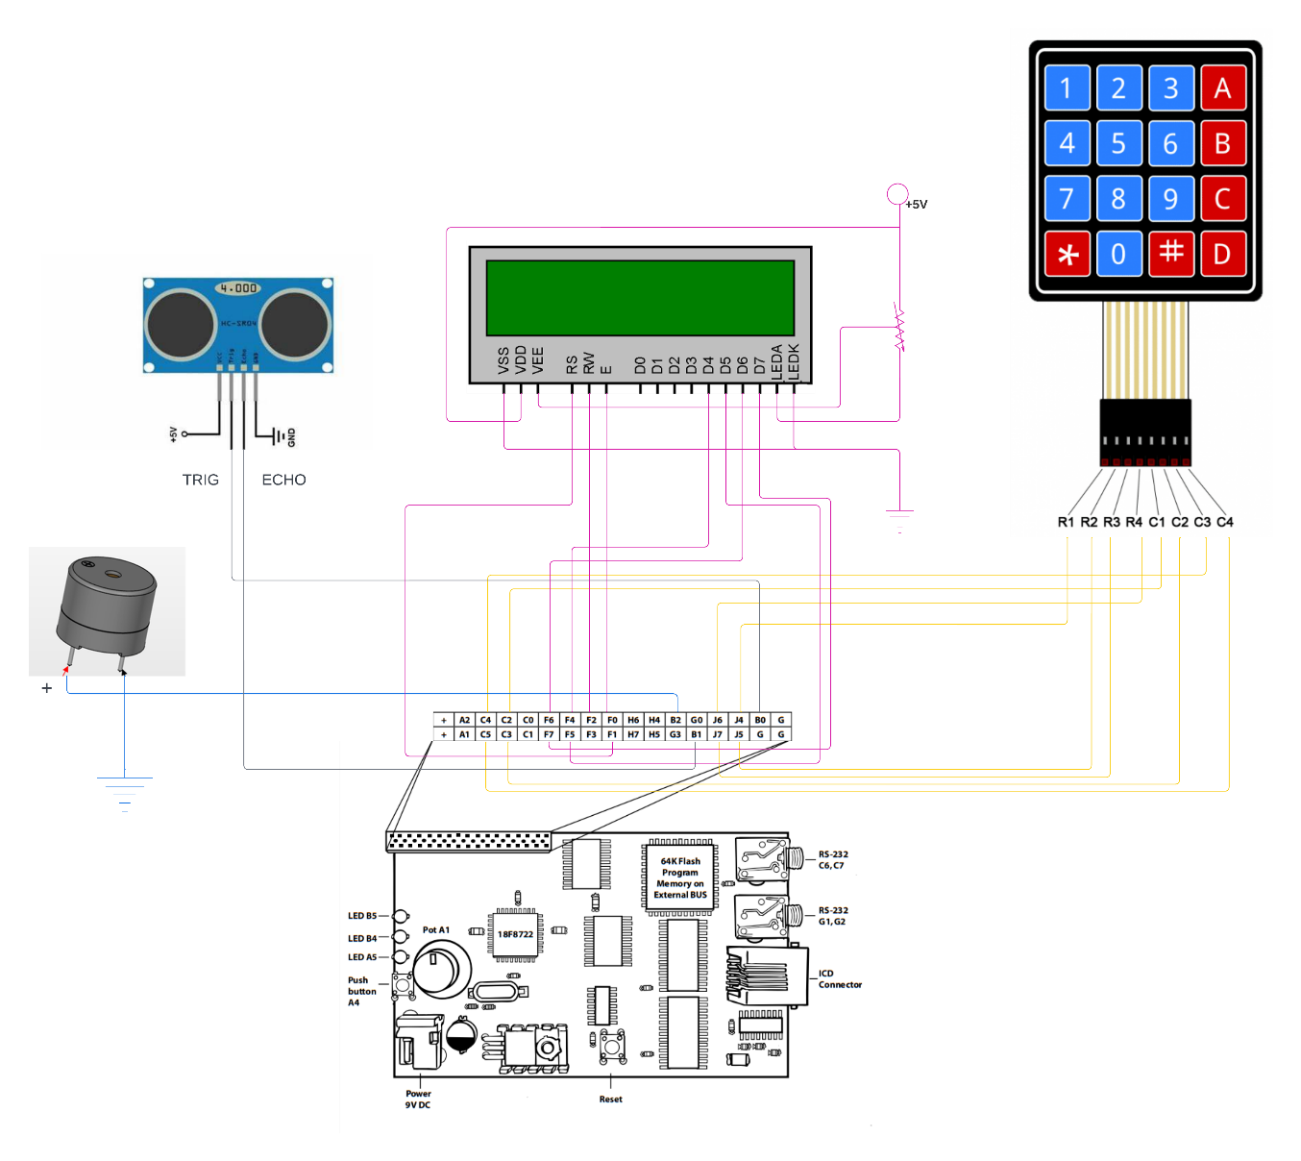

Figure : Final Circuit Set-up

# Software flow chart

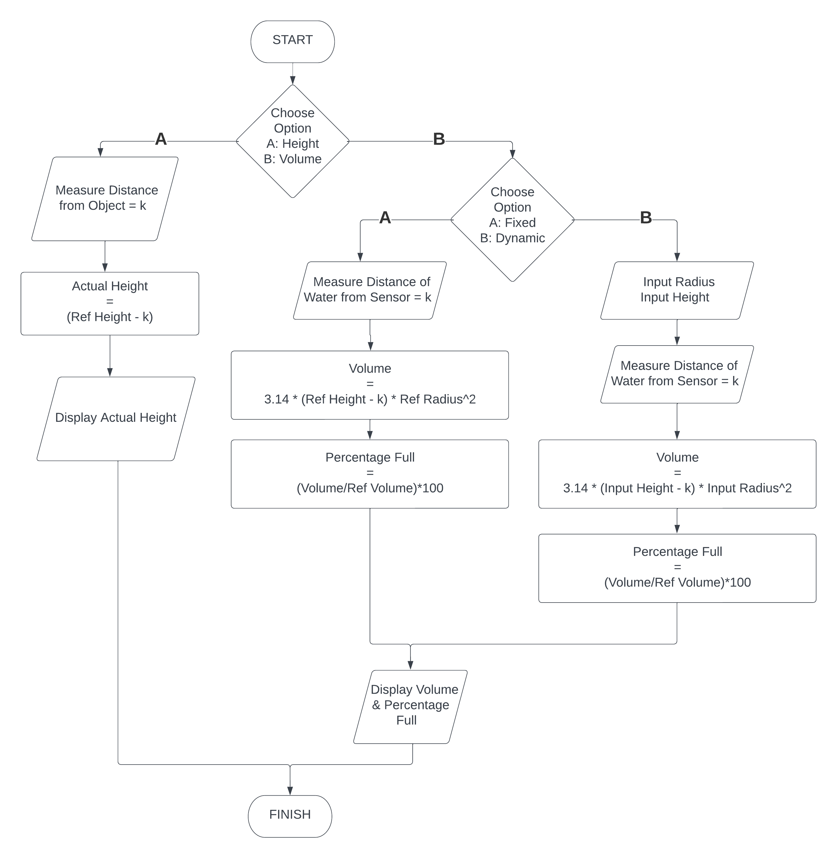

# ****Discussion****

The entire Project Development was split into 5 main steps;

## Step 1 – Part Requirements

The team started off with analyzing the project requirements as mentioned in the Objectives. Fortunately, the parts list was made available to the team, hence, there was not much further discussion on the parts, however, the team discussed potentially adding a Water Flow Sensor to the Project to evaluate the quality and accuracy of the Digital Meter. The team unanimously decided that it would be a safer option to buy every component brand new to avoid any malfunctioning from older parts, especially due to broken pins and ports from past users.

## Step 2 – Testing and Calibration

Once the parts were made available to the team. The first thing was to test out each component separately. As mentioned in the Methodology, the team checked if each component for any potential faults. Afterwards, the team ran trial runs on the LCD Display, Buzzer, and the Ultrasonic Sensor with sample codes that tested the minimum functionality of the parts. Once the parts were tested, the team then went on to calibrate the Ultrasonic Sensor. The Ultrasonic Sensor works by sending in pulses of ultrasonic waves from the sensors, then it waits for the waves to bounce off a surface and return. However, the values that the Ultrasonic Sensor put out were significantly larger than the actual distance an object was from the sensor. Therefore, the team conducted an analysis to find a constant that will help to convert the outputs from the Ultrasonic Sensor to a more logical actual distance measurement as shown in =====. Once the Ultrasonic Sensor was calibrated, the team finalized the brightness level of the LCD Display with the help of the Potentiometer.

## Step 3 – Code Simulation

In order to test out the compatibility of each component with each other, the team were required to connect all the components together and run trial codes again to see if the component could communicate well with the PIC C 18F8722 Microcontroller. However, proper engineering practice includes the use of simulations and virtual tests before connecting any hardware device. This is done to protect the components from any sort of damage and errors from mistakes in connections and trial runs. The Team opted to use TinkerCAD Software to simulate the components and code. There was yet again another limitation on our hands, that being that the TinkerCAD Software only worked with Arduino Boards rather than PIC C 18F8722 Microcontrollers. For the sake of safe guarding the components from any potential damages, the team created a different set of code in Arduino to suit the requirements of the TinkerCAD Software. Once minor adjustments were made to ensure that the final set-up would work fine, the team then converted to Arduino Code into PIC C Code. To the team’s surprise, the conversion of the code was not that difficult. As apart from some minor syntaxes, the logic behind the code remained the same.

## Step 4 – Breadboard Trials

Once the Code Simulations were completed, the team then set-up a circuit on the Breadboard. The Breadboard serves as a temporary medium of connection between the component, at least until the components and the remaining logic was finalized. Using the Breadboard also ensured that none of the Components will receive any permanent damage if a mistake were to occur, fortunately, there were no issues when implementing the Digital Meter onto a Breadboard. The only minor inconvenience was that the connections used to disconnect form the ports whenever, the breadboard was moved from one location to the other.

In the Breadboard trials, the team now started testing the System with different volumes of water, as well as placing objects at different heights to test out the height measurement feature of the System. There were some challenges with this phase, this was mainly since the simulations were done on ideal situations where movement of the object and liquid was not considered. This resulted in the Digital Meter constantly refreshing to update the measurement from the Ultrasonic Sensor, nevertheless, the team realized that the system only needed to display to most appropriate value at a time, therefore, instead of a constant refresh of the values, we team changed the logic of the code to enable the Digital Meter, to display only one value at a specific prolonged interval. Once that issue was sorted, the team had one last step to do before completion.

## Step 5 – Final Set-up and Mounting

After the code was finalized and each component was calibrated accordingly, the final step was to create a mount and permanently fix the components to avoid any wire disconnections during transportation. The team had a prebuilt mount from a former project, however, during the installation process, the wooden mount had snapped in half due to a weak joint. This had created a sudden distress amongst the team but the team maintain decorum and began working on a new mount from scratch. With the help of a few people as mentioned in the Acknowledgement, the team was able to construct a strong mount within a short span of time. Finally, after the new mount was constructed, all the Components of the Digital Meter were fixed and wire management was done to display a neater finished product. The last step in the mounting was to paint the mount to make it appear consistent and aesthetically pleasing.

# Conclusion

To conclude, all of the project specifications have been met, the Digital Meter is able to measure the Height of a person standing underneath the Ultrasonic Sensor, as well as accurately measure and display the volume of liquid that is present in the Cylindrical Storage Container. Moreover, from the demo runs, it can be stated that the Digital Meter is responsive to multiple uses without any failure, in addition, the Meter is able to adapt to different sizes of the cylindrical containers with varying radii. In addition, further adjustments and implementations can be made to improve the Digital Meter, hence, it is recommended that a function be implemented that shall compute multiple results from the Ultrasonic Sensors in a specific time interval and display to most appropriate answer on the LCD for a prolonged time as this will prevent the LCD display to constantly update the output every millisecond. Moreover, another recommendation to improve the functionality of the Digital Meter is to make it mobile by adding a battery powered system as this will prevent the hassle of locating a power source every time the Digital Meter requires usage. Lastly, the team has gained an ocean of knowledge with regards to the PIC C 18F8722 Microcontroller and its integration with various components, therefore, after delivering all the project specifications and learning about Project Development, the Digital Meter Project can be deemed successful.

# Acknowledgement

The Team would like to acknowledge and extend their appreciate to the following person(s) whom have shown tremendous support and contribution to the completion of the Project;

* **Mr. Janendra Singh** – Without access to a workshop, the team would not have been able to build a strong and reliable mount for the Digital Meter on time, Mr. Singh, was gracious enough to offer his workshop and guidance into building the Mount from scratch.
* **Mr. Nikhil Kumar & Mr. Dikshil Kumar** – for being a helping hand in the mount building process as well as being a test subject in the Height Measurement phase of the Project.
* Last but not the least, the **Course Coordinator** and the **Respective Teaching Staffs**, without whom, the team would not be able to grasp the understanding of PIC Microcontrollers and its implementation to the Digital Meter Project.

# List of Figures

Figure 1:Block Diagram for the Digital Meter 1

Figure 2: Circuit Set-up in the TinkerCAD Simulation Software 4

Figure 3: Final Circuit Set-up 5

# References

|  |  |
| --- | --- |
| [1] | "PIC18F8722 Family Data Sheet," Microchip Technology Inc., 2006. [Online]. Available: https://ww1.microchip.com/downloads/en/DeviceDoc/39646E.pdf. [Accessed 5 May 2023]. |
| [2] | S. Singh and A. Agarwal, "Distance Measurement Model using HC-SR04 Ultrasonic Sensor," *Procedia Computer Science,* vol. 85, pp. 395-400, 2016. |
| [3] | H. ElKamchouchi and D. ElShakankery, "Ultrasonic sensors in IoT applications," *Internet of Things,* vol. 11, 2020. |
| [4] | Y. Xiao, H. Yan and H. Wan, "A felxible volume measurement system based on ultrasonic sensor for industrial application," *IEEE Transctions on Industrial Informatics,* vol. 12, no. 5, pp. 1620-1627, 2016. |
| [5] | Y. Liu, Q.Wu and H. Liu, "A novel water measurement method using ultrasonic sensor," *IEEE Transactions on Instrumentation and Measurement,* vol. 67, no. 9, pp. 2153-2162, 2018. |
| [6] | AUTODESK, "Tinkercad," 22 May 2023. [Online]. Available: https://www.tinkercad.com/. |
| [7] | J. B. Peatman, Design with PIC Microcontrollers, Pearson Education, 2008. |
| [8] | M. Barangi, H. Song and W. Jeon, "Smart Water Management System: Concept, Design, and Applications," *IEEE Sensor Journal,* vol. 18, no. 12, pp. 4955-4962, 2018. |
| [9] | S. Y. Foo and Y. Zhao, "Development of a microcontroller-based ultrasonic distance sensor," *IEEE Transactions on Education,* vol. 42, no. 4, pp. 307-313, 1999. |

# Appendix

The following Link contains all necessary data and information collected throughout the development of the Digital Meter Project. The Information ranges from Photos, Older Code Versions to the Project Presentation.

<https://drive.google.com/drive/folders/1lhnJwlVhtKGYVw3fDxG2tByPX8zxNKQ_?usp=sharing>